**PYTHON PROGRAMMING**

**Assignment # 01**

**Submitted By: Maria Farooq**

**Question 01**

**Part 01**

**Write a program to get a string from user and then reverse the string.**

**Method 01:**

I have used two different methods in it. The first one is by defining a function to get the string from user and then reverse that string. This function use slicing in which 3 values start, stop, step are used. As we want to reverse the string so we will move backward , for this -1 will be used as a step that tells about the direction to start from the end.

user_input_string = input("Enter a string: ")

def reversed_string(string):

    return string[::-1] # start, stop and step.. step of -1 will start from backward direction.

print("The reversed string is : " ,reversed_string(user_input_string))

#Method 02 : Using For loop

print("Reverse string using for loop: ")

reverse_user_string = ''

for char in user_input_string:

    reverse_user_string = char + reverse_user_string

print(f"User reversed string is: {reverse_user_string}")

**Method 02:**

The second method is by using for loop in which I have created an empty variable and then store the each character of the string in that variable.

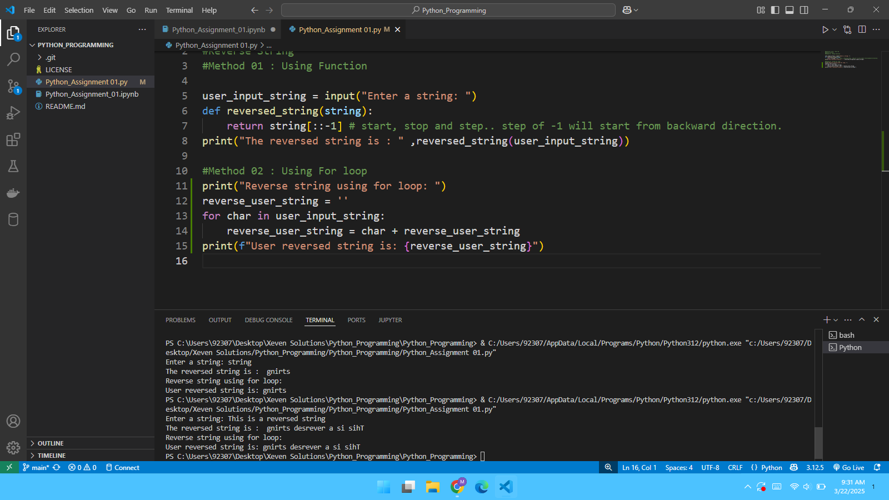

**Part 02**

**Count the number of vowels in the string.**

**Method 01:**

I have used two different methods for this part as well. The first one is using a for loop in which each character of string is stored in a variable named “vowel” and then a function named “lower()” is used to make the charters in lowercase to check that either these characters are present in list ['a','e','i','o','u'] or not. If the character is in vowel list then the character will be added to the variable named “sum_of_vowels” and will be displayed.

#Question 01 : Part 02

#Numbers of vowels in the string

user_input_string = input("Enter a string: ")

#Method 01

sum_of_vowels = ''

for vowel in user_input_string:

    if vowel.lower() in ['a','e','i','o','u']:

        print("Number of vowels: " , vowel)

        sum_of_vowels += vowel

print("Number of vowels: " , len(sum_of_vowels))

#Method 02 : Using a Function

print("Method 02 : Counting number of vowels using a function:")

def check_vowels(string):

    vowels = "aeiouAEIOU"

    return sum(1 for char in string if char in vowels)

print("The vowels in the string: " , check_vowels(user_input_string))

**Method 02:**

The second method is using a function that take a “string” as a parameter and check that the string character is in vowel variable and will add 1 for each character.

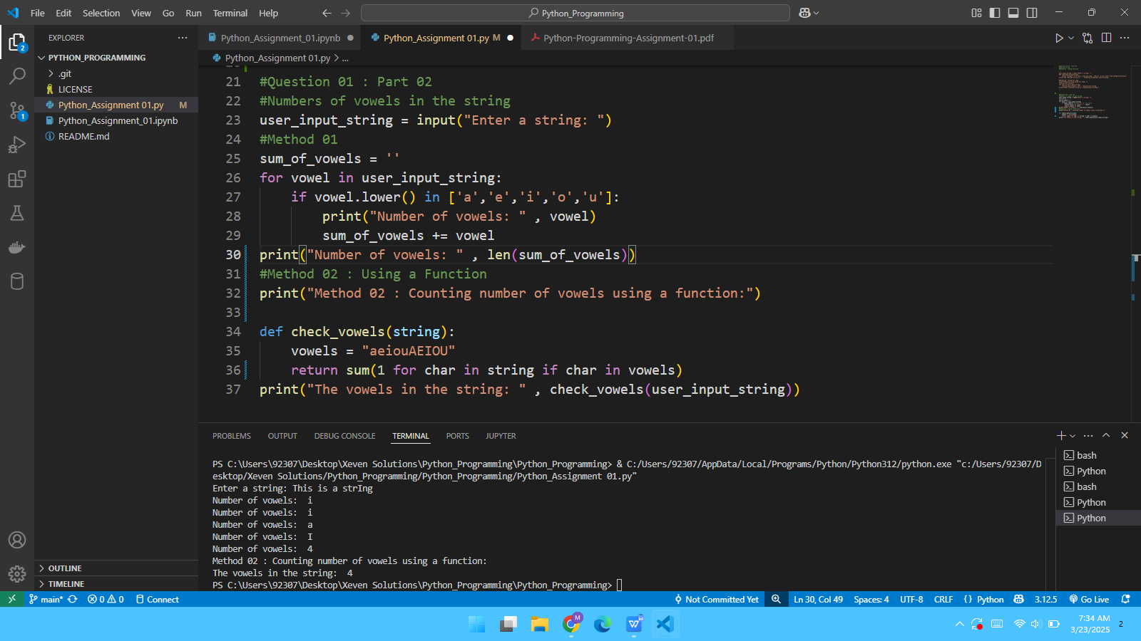

**Question 02**

**Problem: Create a Python program that:**

**● Takes an input number from the user.**

**● Checks whether the number is even or odd.**

**● Prints the result.**

# Question 02

number = int(input("Enter a number: "))

def check_number(number):

    if number % 2 == 0:

        print(f"{number} is an even number")

    else:

        print(f"{number} is an odd number.")

check_number(number)  #When we use print statement inside the function, we do not need to use print here again.

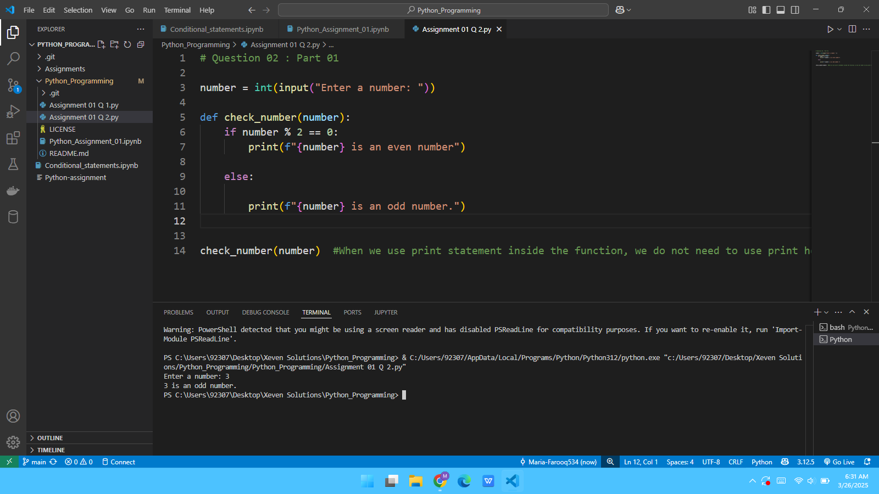

**Question 3:**

**Virtual Environment Application Problem:**

**Create a Python program that:**

1. **Takes a list of integers as input.**

**2. Creates a new virtual environment called sortenv.**

**3. Installs a package (such as numpy) in the virtual environment.**

**4. Sorts the list using a numpy method (numpy.sort()).**

**5. Prints the sorted list.**

* **Takes a list of integers as input.**

* **2. Creates a new virtual environment called sortenv.**

conda create -n sortenv python==3.10

conda activate sortenv

* **3. Installs a package (such as numpy) in the virtual environment.**

pip install numpy==2.2

* **4. Sorts the list using a numpy method (numpy.sort()).**
* **5. Prints the sorted list.**

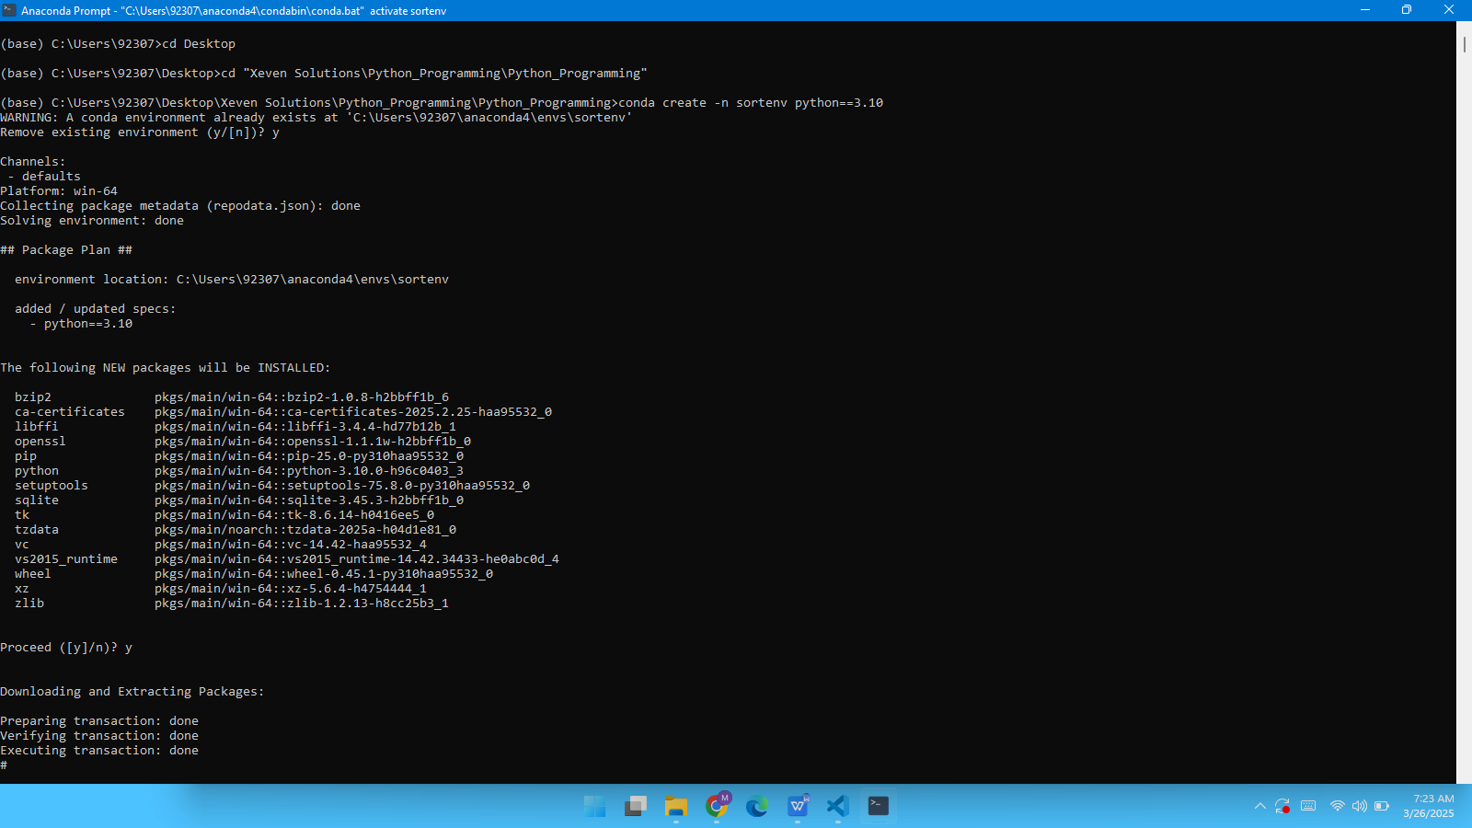

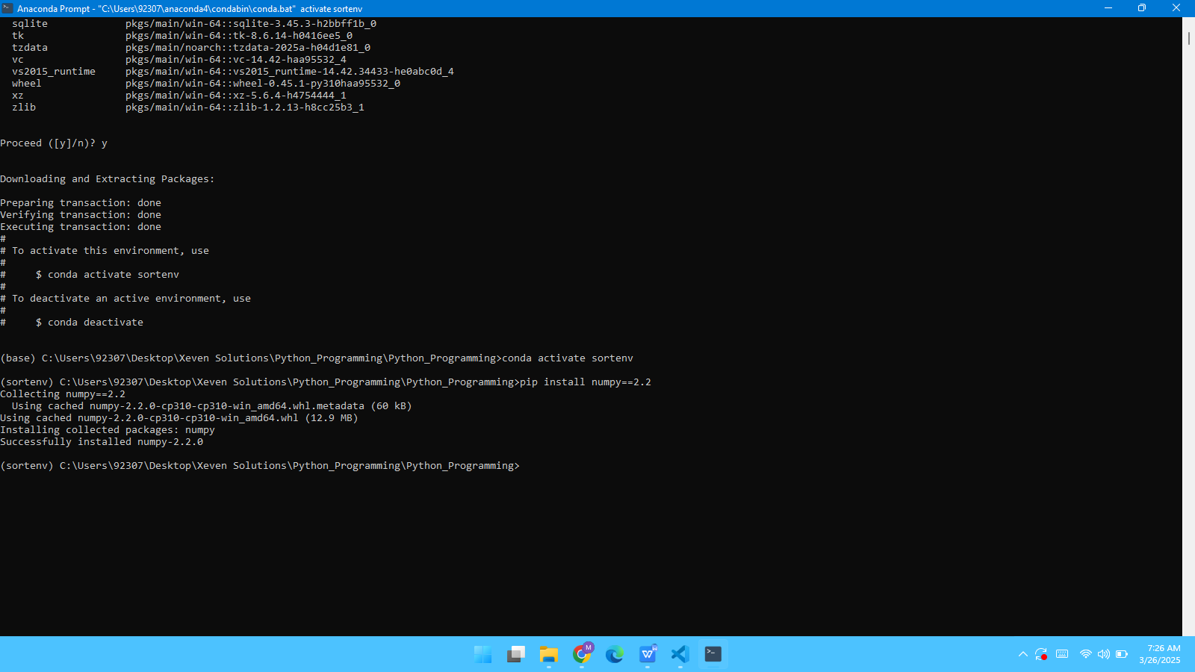

Using Anaconda:

#Using Anaconda

import numpy as np

#Virtual environment setup

def setup_virtual_environment():

    print("Create virtual environment using anaconda by running this command: ")

    print("conda create -n sortenv pythoun==3.12 ")

    print("Activate Environment: ")

    print("conda activate sortenv")

    print("Install Python library: Numpy")

    print("!pip install numpy")

#Sorting array

def sort_list(arr):

    return np.sort(arr)

#Taking input from user

try:

    user_input = input("Enter a list of integers seperated by space: ")

    num_list = list(map(int, user_input.split()))

    print(setup_virtual_environment())

    print("Sorted list: " , sort_list(num_list))

except ValueError:

    print("Invalid Input!")

**Method 02:**

ef sort_list(arr):

    return np.sort(arr)

# Simulating virtual environment setup

def setup_virtual_env():

    print('Step 1: Create a virtual environment using:')

    print(" Python -m venv sortenv")

    print('Step 2: Activate the virtual envorinment')

    print(' Windows: sortenv\\Scripts\\activate')

    print(' macOS/Linux: source sortenv/bin/activate')

    print('Step 3: install NumPy in the virtual environment')

    print(' pip install numpy')

print('Step 4: Now, sorting the list using NumPy...')

Taking user input as a list of integers

try:

    user_input = input('Enter a list of numbers separated by spaces: ')

    num_list = list(map(int,user_input.split()))

    setup_virtual_env()

    print('Sorted list: ',sort_list(num_list))

except ValueError:

    print('Invalid input! Please enter a list of integers.')